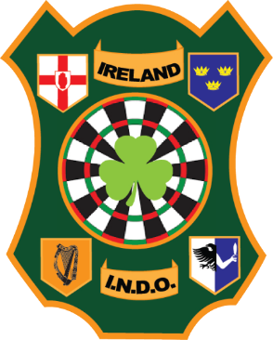
Irish National Darts Organisation
Social Media Policy

1.0 The Irish National Darts Organisation social media sites policy includes but not limited to Facebook, Twitter, Instagram, Youtube and Blog.
2.0 The Organisation has an official Facebook page, used for communication of events, results and the like. Members of affiliated counties are welcome to contribute to discussion and comment on posts.
With this in mind, the Organisation wishes to remind members of their responsibilities when visiting our page, and others which may mention or refer to, the INDO, its’ members, sponsors, or committee.
3.0 This social media policy may be revised at anytime, and sits alongside guidelines outlined in our Youth Protection Policy.
4.0 Any of the following comments or content that include the following on INDO social media sites will be removed:
- Offensive or inappropriate comments
- Obscene or racist content
- Personal attacks, insults, or threatening language
- Comments that advertise commercial products or services. (other than darts related)
- Comments that suggest or encourage illegal activity
5.0 If a member of the committee chooses to become active on any darts related issue, they must state that their comments are their own and not that of the INDO.
Individual members are of course free to express any opinion they wish as long as it does not breach the above guidelines. Everyone is responsible for their own individual actions on social media.
6.0 The INDO has no jurisdiction on any social media platform other than its own official one. However, if a member of an affiliated county has been deemed to breach any of the guidelines set out in this policy elsewhere, resulting in bringing the INDO into disrepute, it would be expected that the administrator of that group, page, or site, report the matter to the General Secretary of the INDO. The INDO reserve the right to communicate such matters to the individual members County board for review.
7.0 County boards have a responsibility to ensure its members are aware of, and are mindful of this policy.
8.0 Any individual who has been deemed to have breached any of the guidelines set out in this policy may have formal disciplinary proceedings brought against them, along with their comments / actions passed over to the Gardai or other relevant authority. The members’ affiliation to the INDO and attendance at INDO events may also be reviewed.

