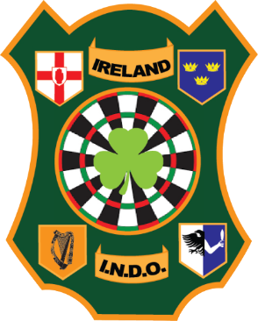
Irish National Darts Organisation
Players Commission Policy

INDO Players Commission
The purpose of the INDO Players Commission is to provide a channel of communication whereby active players will have a formal role in decision-making processes within the INDO.

Responsibilities of the Commission
The responsibilities of the INDO Players’ Commission are:
- Offer assistance and advice to the INDO committee on matters which are relevant to players within the structure of the INDO.
- Submit reports and recommendations to the INDO Committee on matters of relevance to players.
- Present the point of view of the players to the INDO Committee on anti-doping issues and matters concerning the health of players.

Operation
- The Players Commission shall consist of a maximum of five members.
- The Chairperson shall be chosen by the elected members themselves.
- There must be at least two male and one female active players elected at each election.
- The period of office for members of the Players Commission shall be two years.
- The Commission shall be responsible for setting up each meeting and for inviting players to attend.
- The Players Commission shall hold at least one formal meeting each year. This may be done at INDO tournaments if required.
- The Players Commission shall send two players to the INDO Annual General Meeting with having one vote at the AGM.

