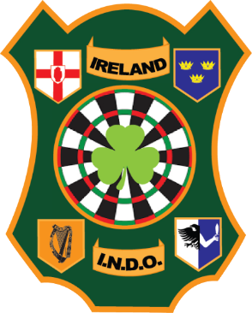
Irish National Darts Organisation
Anti-Doing Policy

Any person entering an INDO darts competition agrees to the INDO non-drug use policy.
Any prohibited substance or illegal substance shall not be allowed in or on any player or official at an INDO darts event.

- Players agree to be drug tested at any time during an INDO run darts competition upon request of any INDO official or any person appointed by the INDO. i.e. A drugs testing officer of the sports council of Ireland.

- Number 1 above is an automatic acceptance on behalf of the player upon entry to any INDO darts event.

- Drugs testing can be done in any way that confirms with the Irish Law, Sports Council Ireland and the World Anti-Doping Agency code.

- Any player that is found in the possession or under the influence of any illegal substance will be immediately suspended from taking part in any INDO run darts event. Suspension will run until the outcome of any disciplinary proceedings and appeals proceedings.

- Any player that has qualified for the Republic of Ireland international team, that is found in the possession or under the influence of any illegal substance at any INDO event (Competitions, Team meetings, committee meetings, international darts events etc) will be immediately suspended until a discipline procedures and appeals procedures are finished.

- INDO committee members are also subject to all the rules above.

- The Irish National Darts Organisation has in place a set of anti-doping rules that all players and officials must abide by. The anti-doping rules for the INDO are consistent with the World Anti-Doping Code (2015 Code) which governs anti-doping internationally.

You can find the Irish Sports Council (2015) & WDF Anti-Doping Rules here

